Vacuum Freeze Dryer

Instruction Manual

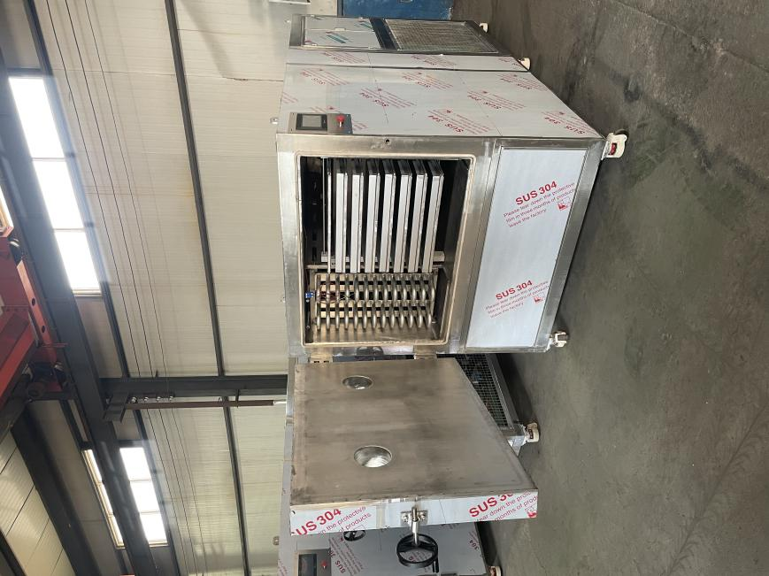

Table of contents
- Model and technical parameters of vacuum freeze dryer...............2
- Working principle of vacuum freezedryer......................................3
- Operation Manual...........................................................................5
- Equipment maintenance.................................................................10
- SeeTroubleshooting........................................................................11
六、Electrical schematic diagram and PLC wiring control diagram.....12 七、Safety precautions...........................................................................16

一、 Technical parameters of vacuum freeze dryer.
Available area of shelf | 10㎡
Maximum water capture | 100kg/bacth
Electric source | 3phase 380V/50Hz
Power | 24Kw
Ply material | Aluminum alloy
Number of layers (blocks) | 13+1 (1 is temperature compensation board)
Aluminum pallet | 660*580*35mm 26 pcs
Arrest board spacing | 70 mm
Ply size (length*width*height) | 1330*600*16mm
Minimum temperature of water trap (no load) | ≤-45℃
Maximum plate temperature | Normal temperature -95℃
Ultimate vacuum (no load) | 10pa
Pipe material | 304 stainless steel seamless steel pipe
circulation pump | 2.2kw
control method | Manual + automatic
Electrical appliances | Chint Electrical Appliances

二、Working principle of vacuum freeze dryer：
Freeze-drying is a technique that uses the principle of sublimation to dry. It is a process in which the dried material is quickly frozen at low temperature, and then the frozen water molecules are directly sublimated into water vapor in an appropriate vacuum environment. The routine result of freeze-drying is called Lyophilization (Lyophilization) , and the process is called Lyophilization.
The substance is always in the low temperature (frozen state) before drying, at the same time, the Ice Crystal is evenly distributed in the substance. Dry Material is spongy porous, the volume is basically unchanged, easily soluble in water and restore the original state. To prevent the physical, chemical and biological denaturation of dried materials to the greatest extent possible.
The lyophilizer is composed of refrigeration system, vacuum system, heating system and electric instrument control system. The main components are drying box, condenser, chiller unit, vacuum pump, heating/cooling device, etc. . Its working principle is to be dried items first frozen to three-phase point temperature, and then in the vacuum conditions of the articles of solid water (ice) directly sublimation of water vapor, removed from the articles, so that the articles dry. After the material is pretreated, it is sent to the quick-frozen warehouse to freeze, then sent to the drying warehouse to sublimate and dehydrate, and then packed in the post-treatment workshop. The vacuum system sets up the low pressure conditions for the sublimation drying chamber, the heating system provides the sublimation latent heat to the material, and the refrigeration system provides the required cooling capacity to the cold trap and the drying chamber. The equipment adopts high-efficiency radiation heating, the material is heated evenly, the equipment adopts high-efficiency water-catching cold trap, and can realize fast defrosting, adopts high-efficiency vacuum unit, and can realize oil-water separation, adopts parallel centralized refrigeration system, multi-channel cooling according to demand, the working condition is stable, it has advantages of energy saving, high control precision and easy operation by artificial intelligence control.
The quality requirements of freeze-dried products are: Constant biological activity, uniform appearance, full shape, firm structure, fast dissolving speed and low residual moisture. To obtain high-quality products, freeze-drying theory and technology should have a more comprehensive understanding. The freeze-drying process includes three stages: pre-freezing, sublimation and re-freeze-drying. Reasonable and effective shortening of freeze drying cycle in industrial production has obvious economic value.
- Product freezing：
When the solution was rapidly frozen (10 ~ 50 °C per minute) , the grains remained the size visible under the microscope, whereas when the solution was slowly frozen (1 °C/MIN) , the crystals formed were visible to the naked eye. The Coarse Crystal leaves a large gap in sublimation, which can improve the freeze-drying efficiency, the gap left by crystallization after sublimation is smaller, which blocks the sublimation of the lower layer, and the quick-frozen products have fine particles, uniform appearance, large specific surface area, good porous structure, and fast dissolution speed, so that the finished product is relatively stronger than the type of moisture.
- The condition and speed of sublimation：
When the Saturated Vapor pressure of ice is higher than the partial pressure of water vapor in the environment, the sublimation of ice can begin.
The distance a gas molecule travels between successive collisions is called the Mean free path, and it is inversely proportional to the pressure. At atmospheric pressure, its value is very small, the sublimation of water molecules and gas easily collide back to the surface of the steam source, so the sublimation speed is very slow. As the pressure decreases below 13.3 PA, the Mean Free Path increases by 105 times, making the sublimation speed significantly faster,The water molecules that fly out rarely indicate their direction, resulting in a directed stream of steam.
Vacuum pump in the lyophilizer plays a role in the removal of permanent gas, a maintenance sublimation of the necessary low-pressure. 1g water vapor expands to 10,000 litres at 13.3 PA and 1.25 L at atmospheric pressure, making it impossible for an ordinary vacuum pump to remove such a large volume per unit of time. The condenser actually forms a vacuum pump designed to trap water vapor.
The product and the condensation temperature are usually-25 °C and-50 °C. At this temperature, the saturated vapor pressure of ice is 63.3 PA and 1.1 PA, respectively, which results in a considerable pressure difference between the sublimation surface and the condensation surface. If the partial pressure of the non-condensable gas in the system can be neglected, it will cause the product to sublimate out of the water vapor, a certain flow rate of directional to reach the surface of the condenser icing.
The sublimation heat of ice is about 2822J/g, if the sublimation process does not supply heat, then the product has to reduce the internal energy to compensate for the sublimation heat, until its temperature and condenser temperature balance, the sublimation also stopped. In order to maintain the temperature difference between sublimation and condensation, only enough heat must be provided for the product.

- The sublimation process
In the first stage of heating up (mass sublimation stage) , the temperature of the product should be lower than one range of eutectic point. Therefore, the shelf temperature should be controlled. If the product is partially dry but the temperature exceeds its eutectic point, the product will melt. At this time, the melted liquid will be saturated with ice but not saturated with solute, therefore, the dry solute will quickly dissolve into, and finally concentrate into a thin stiff block, the appearance is very bad, the dissolution rate is very poor, the melting of meat products occurred in a large number of post-sublimation, then because the amount of liquid melted is less, therefore, it is absorbed by the dry porous solid, resulting in some defects of the block after freeze-drying, and the slow dissolution rate can still be found when water is added. In a large number of sublimation process, although shelf and product temperature is very different, but because the board temperature, condenser temperature and vacuum temperature basically unchanged, so sublimation heat is relatively stable, product temperature is relatively constant. As the product is dried from top to bottom, the resistance of ice sublimation increases gradually. The product temperature will also rise slightly. Until the ice crystals are invisible to the naked eye. At this point more than 90% of the water has been removed. A large number of sublimation process has been basically completed, in order to ensure a large number of products sublimation finished, the board temperature still need to maintain a stage after the second stage of warming. A few percent of the remaining water is called residual water, which differs from free water in physical chemistry properties. Residual water consists of chemically combined water and physically combined water, such as combined crystal water crystals, hydrogen-bonded water for proteins and adsorbed water on solid surfaces or in capillaries. Because the residual water is bound by some kind of gravity, its saturated vapor pressure is reduced in different degrees, so the drying rate is obviously reduced. Although the gasification of residual moisture is promoted by raising the temperature of the product, the biological activity may decrease sharply if the limit temperature is exceeded. The maximum drying temperature to ensure the safety of the product should be determined by experiment. In the second stage, we usually keep the plate temperature at + 30 °C and keep it constant. At the beginning of this stage, the temperature of the product rises quickly because the plate temperature rises and the residual moisture is little and not easy to be gasified. But as the product temperature and the plate temperature gradually approach, the heat transfer becomes more slow, need to be patient to wait for a long time, practical experience shows, the residual water takes almost as long to dry as to sublimate in large quantities, and sometimes longer.
- lyophilization curve
The freeze-drying curve can be obtained by recording the changes of shelf temperature and product temperature with time. The typical freeze-drying curve divides the shelf temperature rising into two stages, the shelf temperature is kept low when a lot of sublimation, and the shelf temperature is appropriately raised in the second stage according to the nature of the product. If the product performance is not clear, poor machine performance or its work is not stable enough, this method is also relatively safe. If the product has a high eutectic point, the vacuum of the system can be maintained well, and the condenser has sufficient cooling capacity, the shelf temperature can be raised to the maximum allowable temperature at a certain heating rate until the end of freeze-drying, but also need to ensure that the product in a large number of sublimation temperature should not exceed the eutectic point. If the product is unstable to heat, the second stage plate temperature should not be too high. In order to increase the sublimation speed of the first stage, the shelf temperature can be raised above the maximum temperature allowed for the product at one time, although these two methods have a lot of sublimation speed, but its ability to reduce interference, vacuum and refrigeration capacity of the sudden reduction or power failure may make products melt. Reasonable and flexible to master the first way, is still the more commonly used way.
- Operating instructions：
1,FREEZE DRYING PROCESS:
Raw materials → plate loading after pre-treatment → pre-freezing → entering the drying Bin → closing the bin door → starting refrigeration → starting the vacuum pump → setting the heating temperature → starting the heating → drying the end, stop Heating → stop vacuum pump → stop refrigeration → lift vacuum → discharge → defrosting
2, Power Requirements: 380 ± 5, three-phase four-wire, frequency 50 HZ
3, wiring requirements: the total power line to be greater than the matching models of lyophilizer total power load current load, reliable grounding line. There are open phase and phase sequence protection in the electric control cabinet, adjust the power line corresponding to phase sequence protection.
- Preparation before starting up
①Before starting the machine, first check whether the power is connected, close all the air switches in the electric control cabinet and the emergency stop switch on the revolving release cabinet door.
②Check whether the water level of the water tower or water tank is normal.
③Close Drain Valve, Frost Valve, Air Valve.
④Check the oil level of refrigerator, vacuum pump, electric heating oil tank is normal.
⑤Parameter setting.

5. POWER ON MANUALLY:
When the device is powered up, the touch screen displays the page:

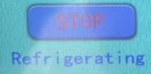
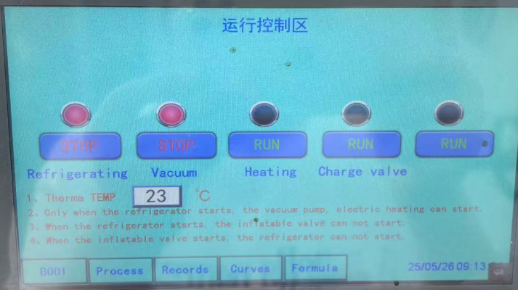
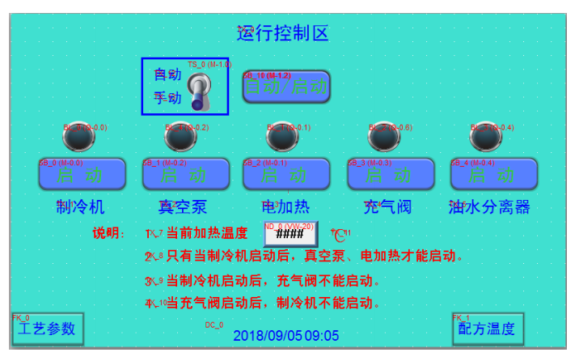

- Press, start the refrigerator, such as a number of chillers, will start in turn, to prevent starting at the same time, the shock current is too large.
- Press,Quickly put the pre-frozen material layer into the drying bin and Insert the temperature sensor, close the door and lock the handwheel.




- Press,Vacuum pump start-up
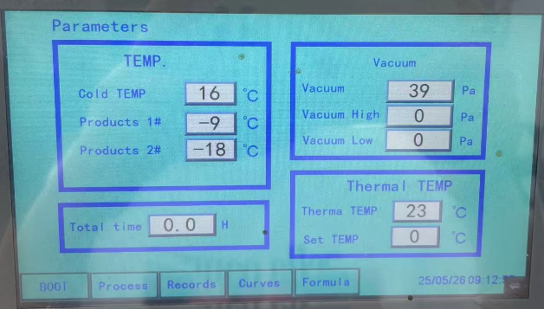

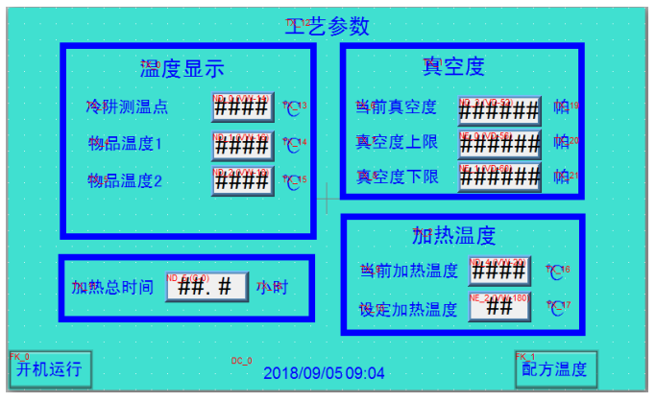
- Press,ENTER THE PARAMETER SETTINGS SCREEN:

The left side of the page shows the refrigeration temperature of the cold trap temperature point and the item temperature of the 2 temperature points. Is Not set, it will as the operation of the equipment, show the current refrigeration temperature and the item temperature. The top right of the page shows the current vacuum level as the device is running. The vacuum upper limit and the vacuum lower limit are used to set the vacuum regulation. For example, when the vacuum upper limit is set at 50Pa and the vacuum lower limit is set at 30Pa, the current vacuum will be automatically adjusted between 30PA and 50Pa. The bottom right of the page is used to control the heating temperature, such as: The temperature setting is 65 °c, the current heating temperature is automatically controlled to 65 °C, the difference of 2 °C. When the parameters are set, observe the item temperature. When the item temperature drops below the eutectic point of the item (general fruits, vegetables, edible fungi and other items in-20 °C have exceeded the EUTECTIC point) , return to the BOOT page, CLICKStart the electric heating and hot oil circulation pump, the articles start to sublimate and dry. In the drying process according to the actual situation, timely adjust the heating temperature and vacuum degree. Note: There is no air compressor for lyophilizer smaller than Zdg30, and the temperature measuring points are 2. The rest is the same.

6.Auto boot
① SWITCH TO AUTO PAGE:


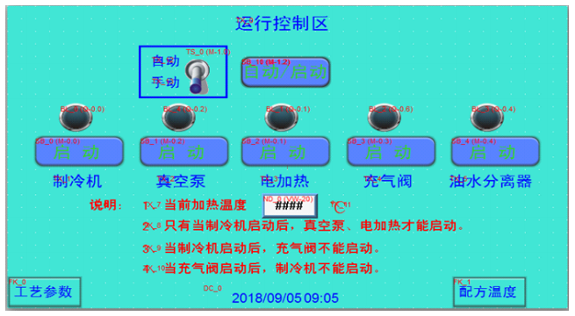
②The boot sequence is the same as manual, except that the formula temperature and vacuum upper and lower limits are set first (same as manual mode) .

③ Click Go to the settings page:
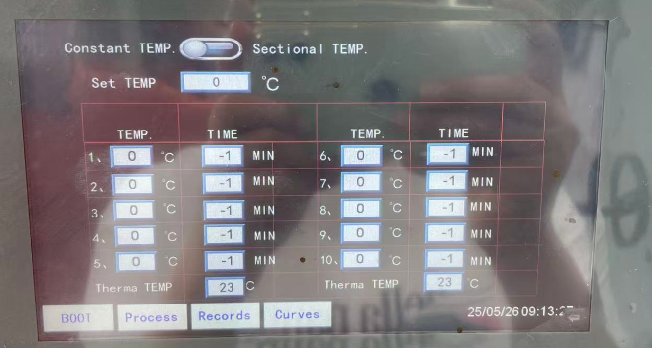
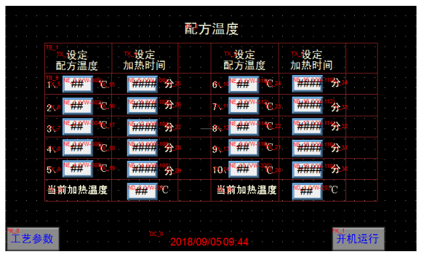
④The formula has a total temperature of 10. The user sets the heating temperature and time according to the actual situation of the processed article. The operation is as follows: Click on the first paragraph of the set temperature formula corresponding to the next box 0 °c, the page will automatically pop up the number key, click on the number 9 to set the required temperature, press the confirmation key to confirm. Then click the heating time corresponding to the next box points, click the number of settings required time, 0 ~ 999 minutes can be arbitrarily set, press OK key confirmation. Then set the second paragraph, the third paragraph, the tenth paragraph, when not needed to adjust the heating time to 0 minutes.

⑤Click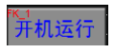Back to boot page.

⑥ClickThe refrigerator starts first, the vacuum pump is pneumatic in turn, the electric heating starts again, the equipment will run automatically from the first stage according to the set temperature and time. If the First Section set the formula temperature 40 °C, set the time for 30 minutes, automatic control equipment heating, heat temperature 40 °C, run 30 minutes into the second section, and so on.


⑦Click Enter the page, can observe the current heating temperature operation and cold trap temperature, item temperature, vacuum degree changes.

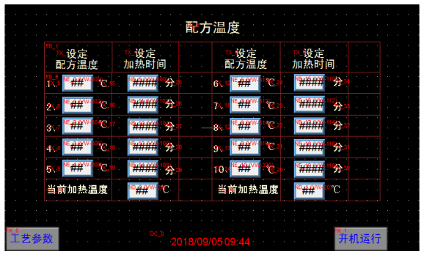
- Judgment of the drying end point: The drying end point can be determined according to the changes in the temperature of the articles. The end of drying can be judged when the material temperature and the shelf heating temperature are basically the same and remain unchanged for a period of time.
- Shut down

Determine the end of drying, with this power cut heating, vacuum pump, refrigerator. Click
Deactivate the vacuum. When the vacuum is completely removed,. Open the drying barn door and take out the goods.
- DEICING
Manually open the drain valve and the intake valve of the sump to deice. Watch the ice from the observation hole, close the inlet valve when all the ice on the water storage pipe is finished, and close the drain valve when the water in the sump is completely drained.
10.Operation of oil-water separation pump
Each complete one or two drying cycle, it is necessary to operate an oil-water separation pump. Before starting the oil-water separation pump, first open the drain water ball valve to empty the water. After the water is drained, close the Drain Ball Valve and start the oil-water separation pump. Then manually open the drain valve of the oil-water separator and observe the oil level mirror of the vacuum pump. When the oil level reaches two-thirds, close the drain valve and keep the vacuum pump in standby condition.
- Maintenance and repair of equipment：
1, daily check 1 tension vacuum pump "V" belt. 2 clean the interior of Radiation Plate and vacuum chamber. The oil level of the tank should be higher than 1/3 of the oil mirror. 2, regularly check the operation of vacuum freeze drying equipment, in the shutdown state, in order to operate again to start smooth and normal work, the shutdown state of the equipment for the necessary inspection, maintenance and maintenance operations. (1) before the operation of the regular inspection 1 refrigeration system inspection, check the refrigeration compressor oil level line, should be in the middle of the oil mirror around the position. Note: This oil level line will fluctuate during operation. Check the refrigeration system pipeline oil leakage, in particular, the copper nut where the lock, where oil leakage will generally leak refrigerant. Remove the dust on the air condenser to ensure the cooling effect. Vacuum pump inspection, check the color of vacuum oil, oil should be discharged in a timely manner, this is because the vacuum pump in operation, inevitably mixed with some water. Check the "V" belt tension, generally in the middle of the hand down, and the original position concave down about 15 mm, too loose should be adjusted. 3 clean all layers of radiant board in vacuum drying chamber, Rinse with water if necessary. (2) regular inspection Operation 1 after operation to clean up the water in the equipment. 2 cleaning the radiation plates in the vacuum drying chamber. Vacuum the vacuum chamber (to prevent the vacuum chamber from rusting into the water) . 4 Rows of residual water in the SUMP.
- EQUIPMENT FAILURE AND SOLUTIONS:
Due to the high professional equipment, if there is a running obstacle, please contact the manufacturer in time.

